My name is Carrot. I grow
Underground and I’m a root.
My shape is like long cone
And my clour is orange.
I’m riche in the vitem C

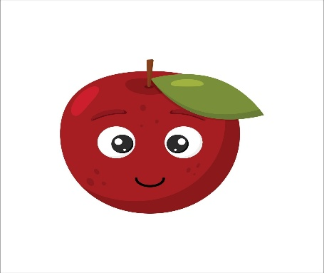
The Ant and The Apple
Art had an apple.
An ant asked Art for a bite.

Art gave the ant a bite
Art and the ant ate the apple.
After they ate the apple
The ant went away.
The Moral is =WE have to share to our friends ok na

